 | $$y=−2,5$$ | $$y=(x+2)^{−1}$$ | $$x=5$$
 |  | $$y=−\frac{1}{3}(x+2)^{2}+2$$

 | 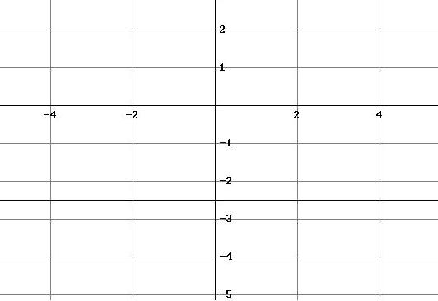 | 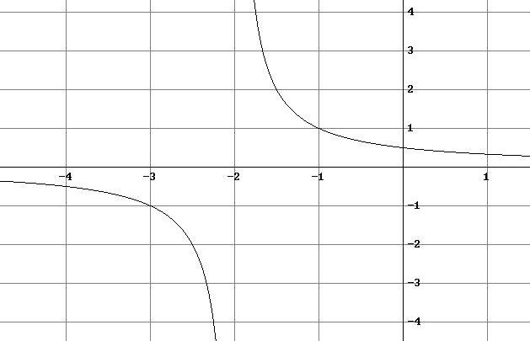 | 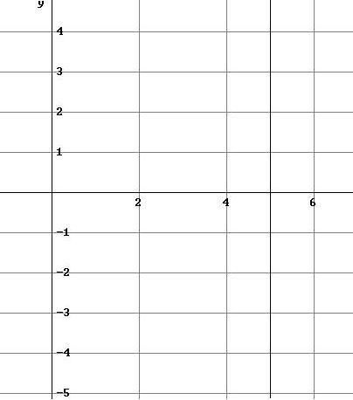
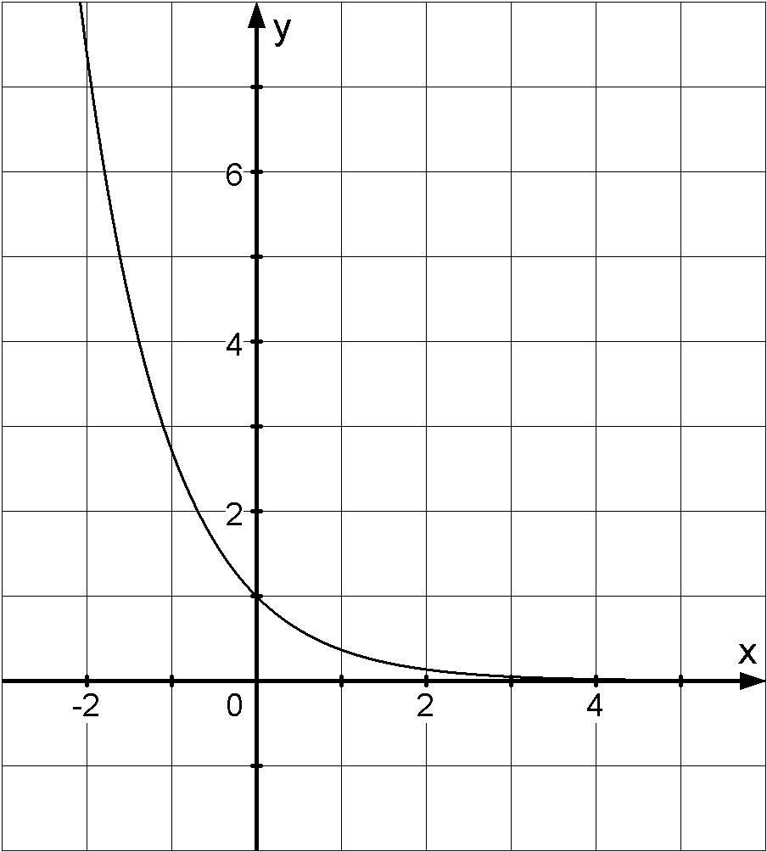 | 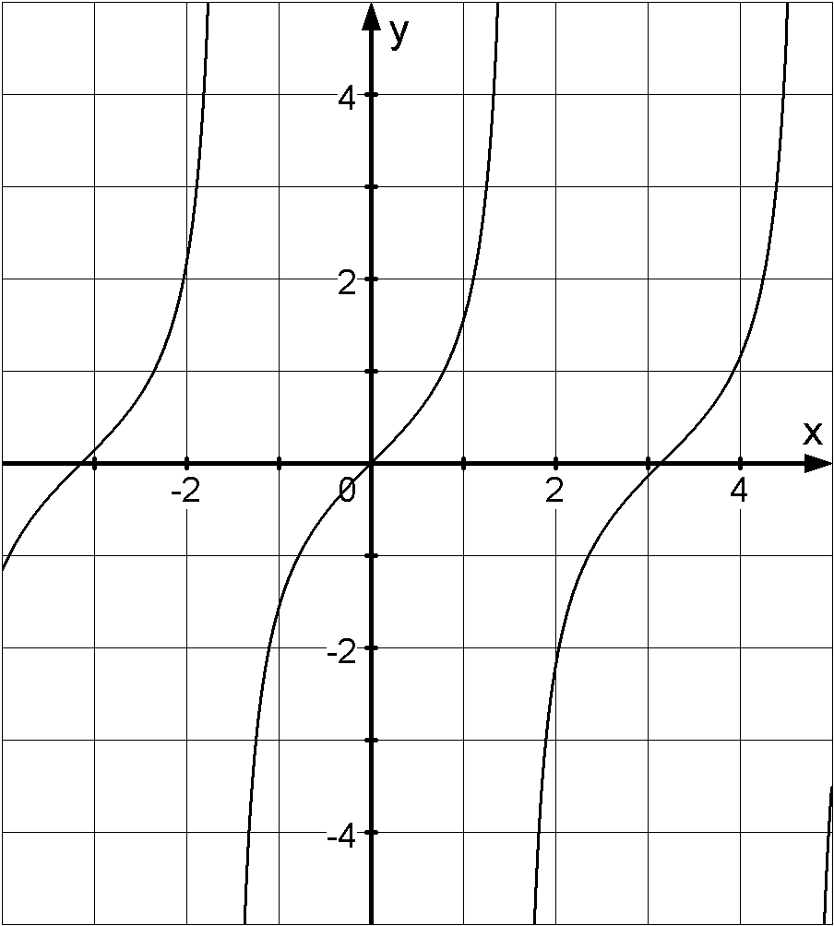 | 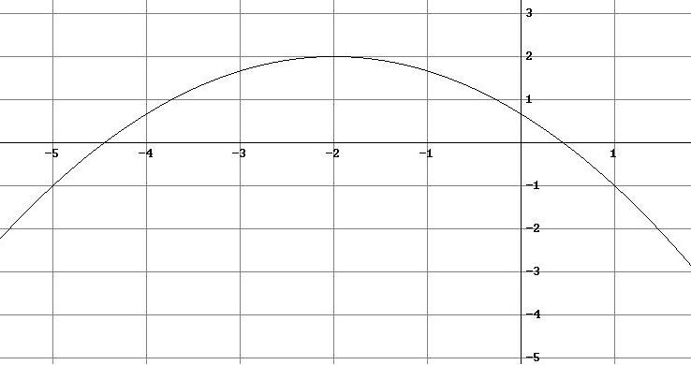 | 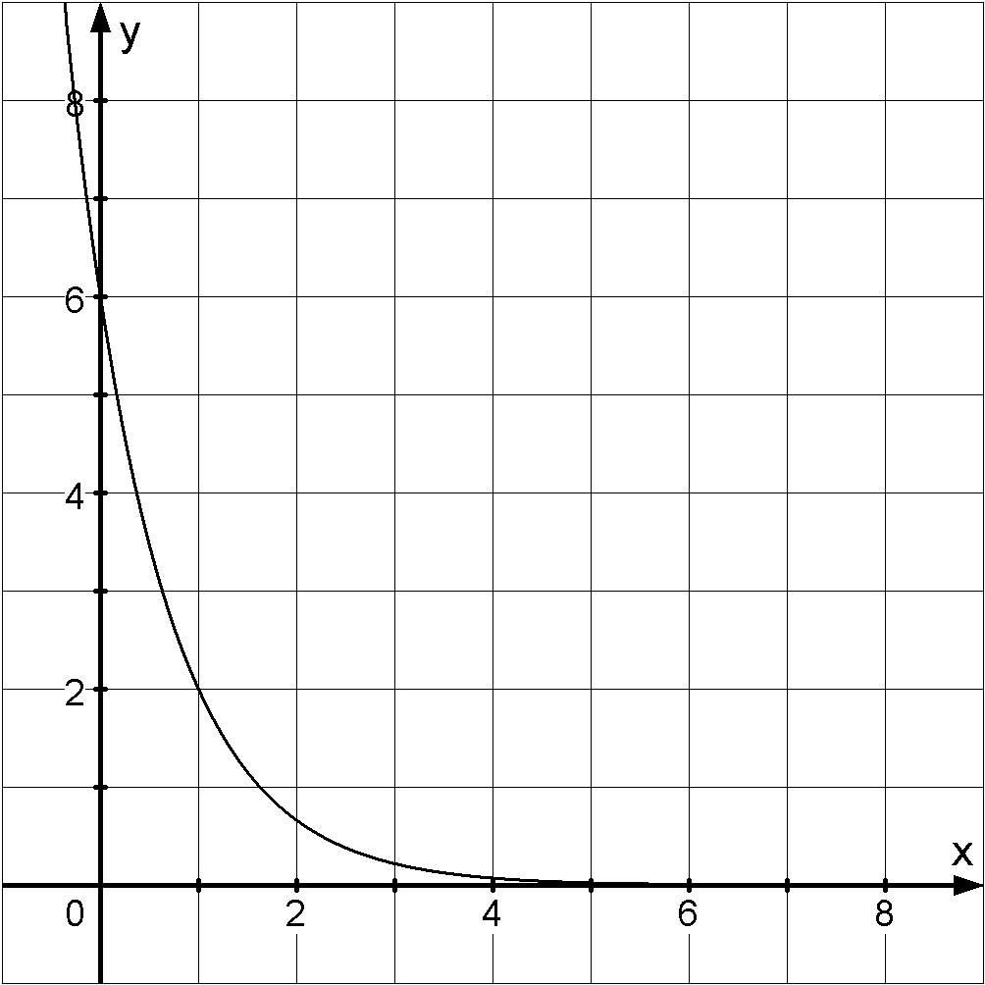

$$y=x^{3}$$ | $$y=−x^{3}+2$$ | $$y=(x−3)^{2}+5$$ | $$9=x^{2}+y^{2}$$
$$(x+3)^{2}+(y−2)^{2}=4$$ | $$y=\text{cos}(x)$$ | $$y=\text{sin}(x)$$ | $$y=4(x−3)^{2}−2$$

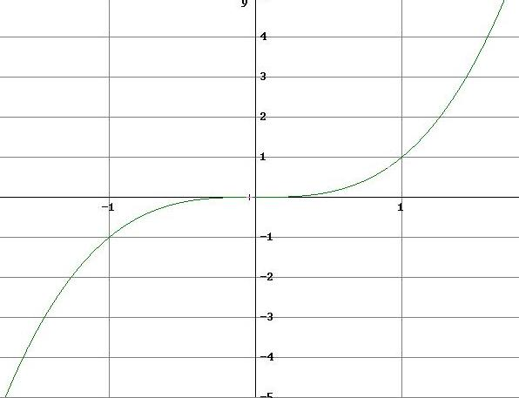 | 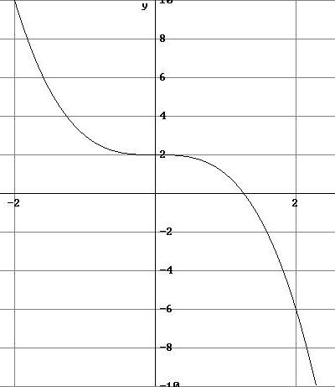 | 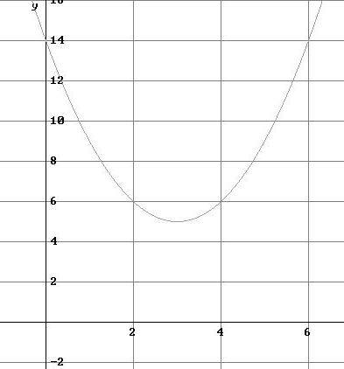 | 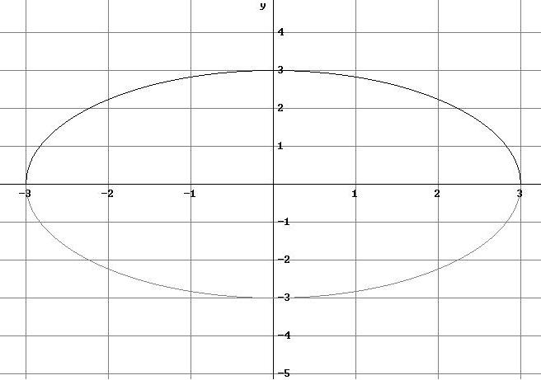
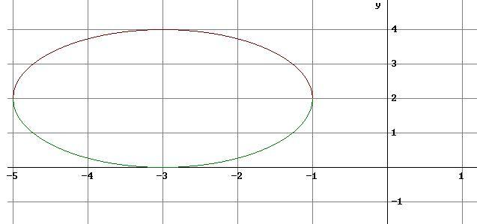 | 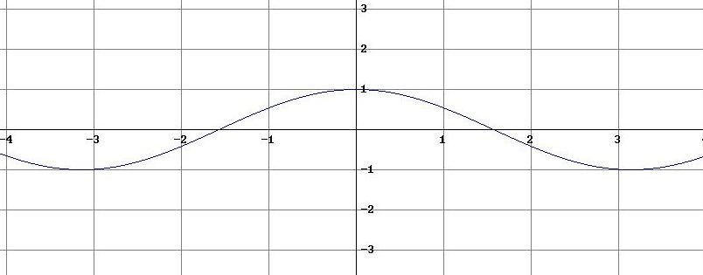 | 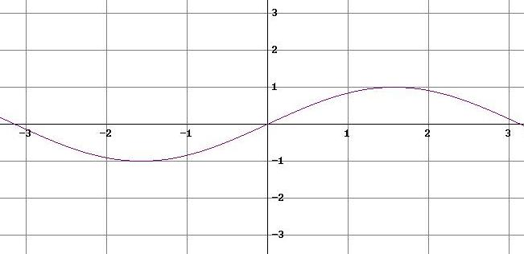 | 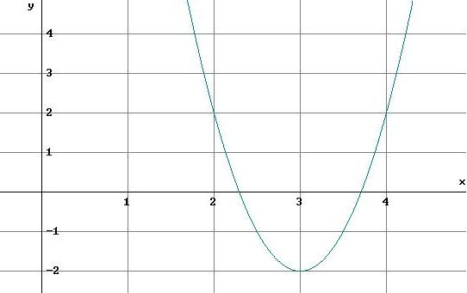

$y=−3x−1$ | $$y=x²+1$$ | $$y=1−x²$$ | $$y=5x−2$$
$$y=\frac{2}{x}$$ | $$y=\left|x−1\right|$$ | $$y=\frac{1}{x^{2}}$$ | $$y=\sqrt{x+1}$$

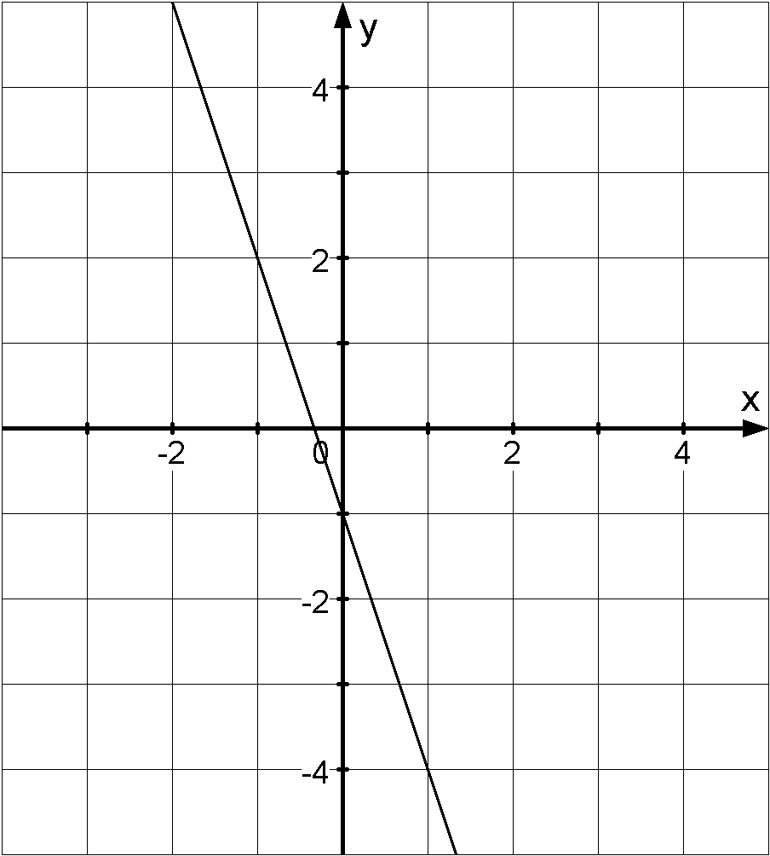 | 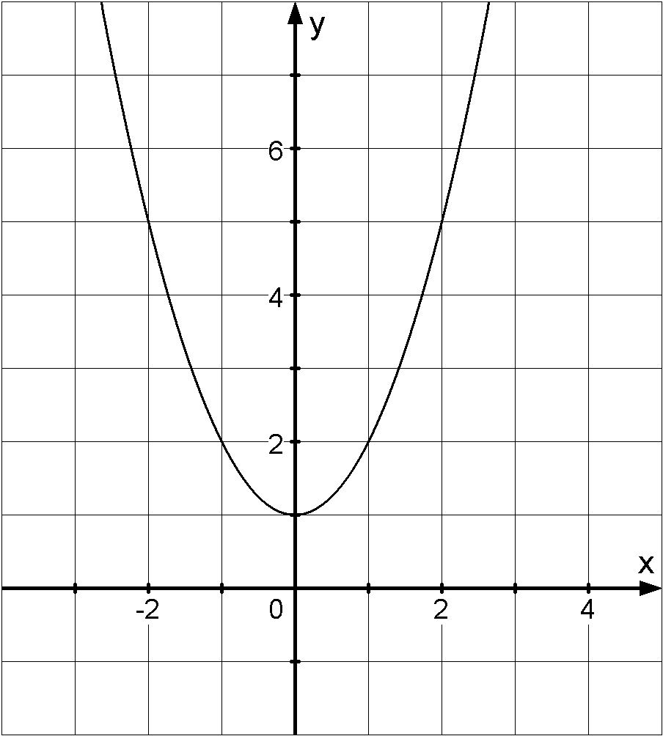 | 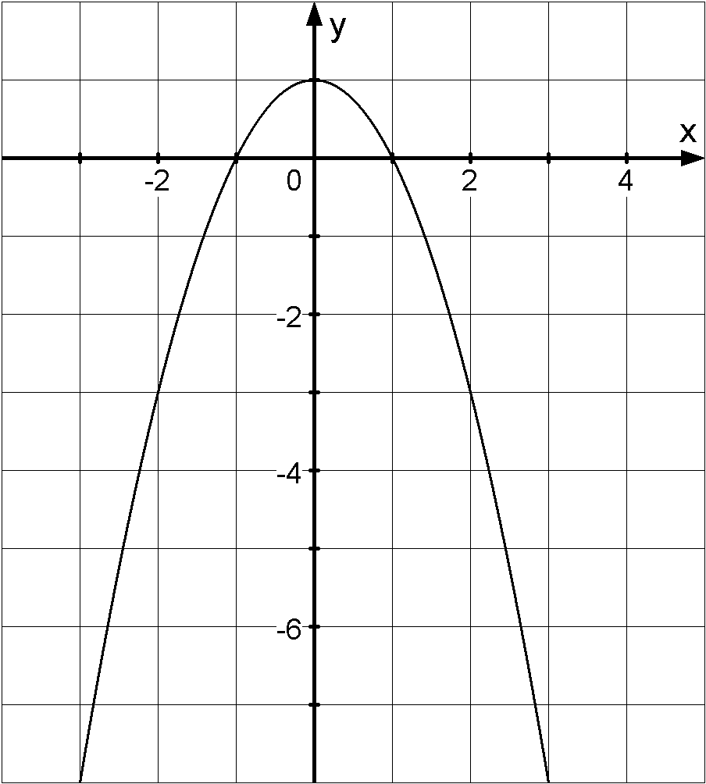 | 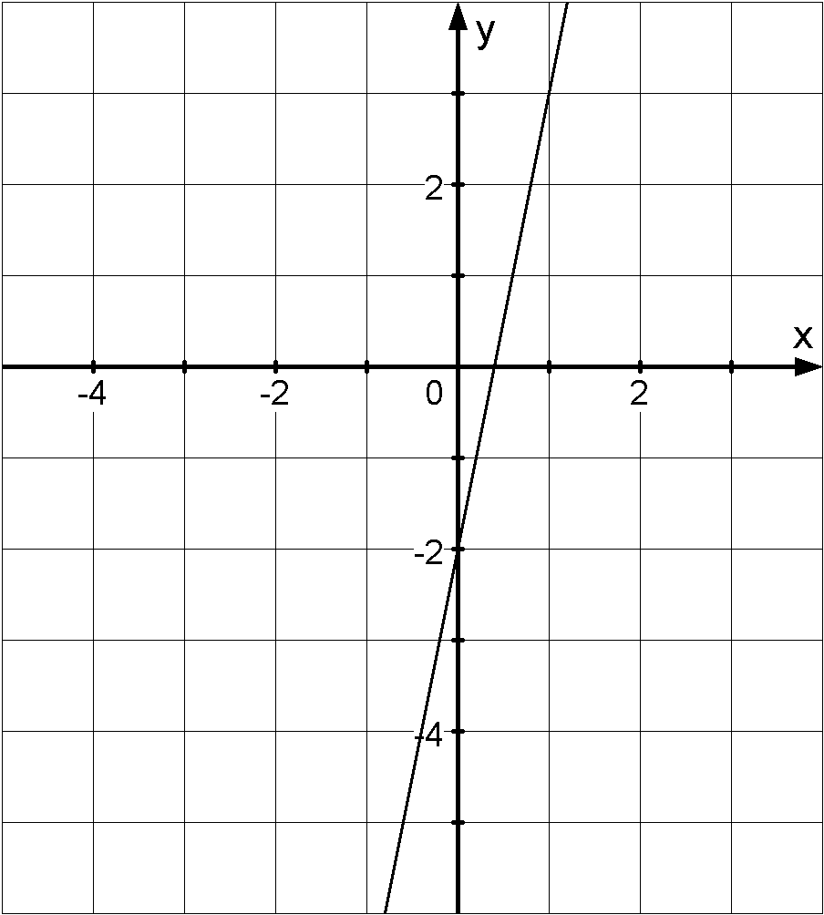
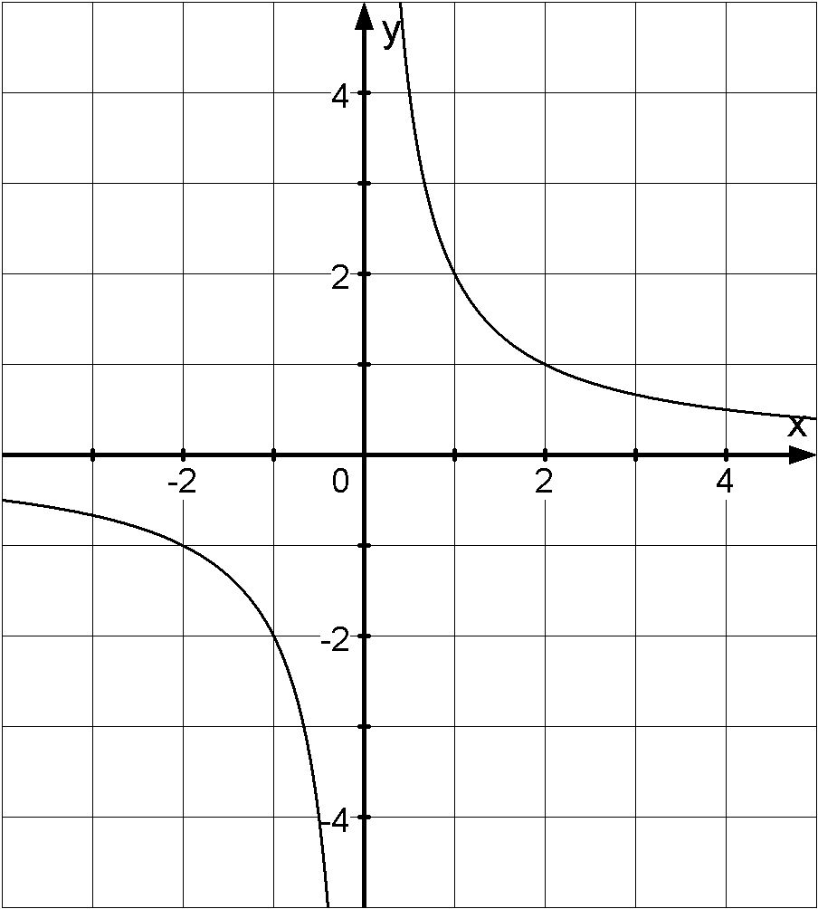 | 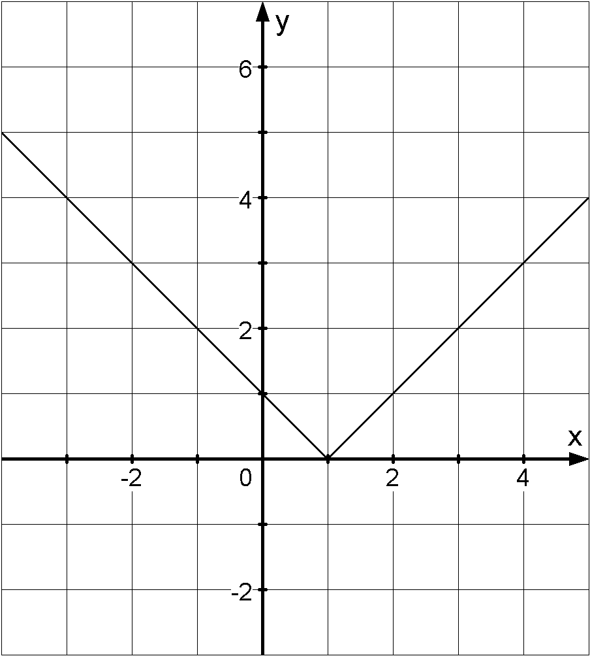 | 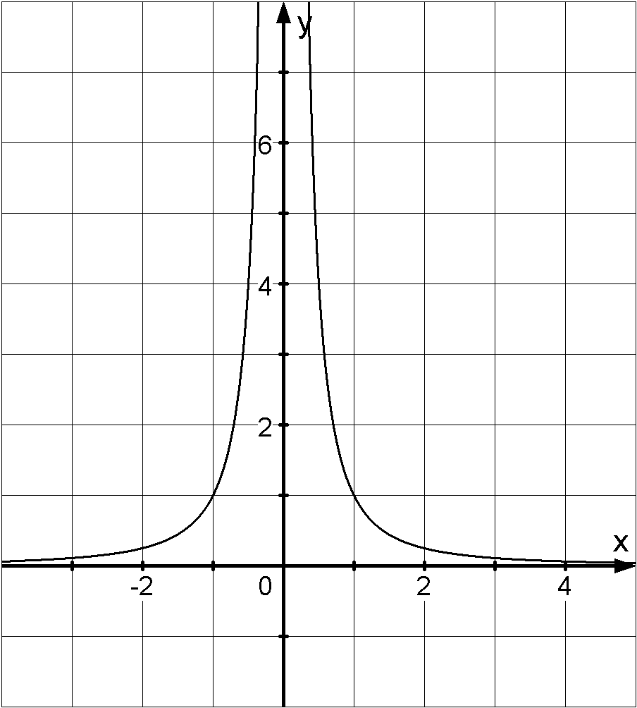 | 